./

GENESIS - Learning Outcome & Mini-project Summary Report



|  |  |  |  |  |  |
| --- | --- | --- | --- | --- | --- |
| **Ver. Rel. No.** | **Release Date** | **Prepared. By** | **Reviewed By** | **To be Approved** | **Remarks/Revision Details** |
|  |  |  |  |  |  |
|  |  |  |  |  |  |
|  |  |  |  |  |  |
|  |  |  |  |  |  |
|  |  |  |  |  |  |

**Details**

Contents

Contents 3

Miniproject -1 [Team/Individual] 4

Module/s 4

Topic and Subtopics 4

Objectives & Requirements 4

Design 4

Test Plan 4

Implementation Summary 4

Video Summary 4

Git Link 4

Git Dashboard 4

Summary 4

Individual Contribution & Highlights 5

Summary 5

Challenges faced and how were they overcome 5

Future Scope (If applicable) 5

Miniproject -2 [Team/Individual] 6

Module/s 6

Topic and Subtopics 6

Objectives & Requirements 6

Design 6

Test Plan 6

Implementation Summary 6

Git Link 6

Git Dashboard 6

Summary 6

Individual Contribution & Highlights 6

Summary 6

Challenges faced and how were they overcome 6

# Mini Project -1 [Individual]

## **Module/s**

“Modules linked to the Mini project are Linux, C++ and SDLC”

### Topic and Subtopics

* **Core topics implemented**:

1. Classes and Objects

2. Inheritance

3. Vectors and list

4. threads

* **Sub topics** **implemented**

1. strings

2. constructors and destructors etc.

* **Linux Concepts used:**

1. Make files for the execution of the project.
2. Static and Dynamic libraries for the faster execution and quicker run time.

## Objectives & Requirements

**Objective**: Smart Library Management System comprising of Books Management, Members Management, Store Management and Utilities Services.

**Requirements:**

**High Level Requirements:**

|  |  |
| --- | --- |
| ID | Description |
| H1 | Management of Book Information |
| H2 | Management of Library Member Information |
| H3 | Store Management |
| H4 | Provide library Utilities to Members |

**Low Level Requirements:**

|  |  |
| --- | --- |
| ID | Description |
| L1 | Get the information about book |
| L2 | List out books which can be borrowed to member. |
| L3 | Set the information about book. |
| L4 | Get Member information |
| L5 | Set Member Information |
| L6 | Get Member borrowed books count |
| L7 | Check whether Member has borrowed books |
| L8 | Find Member by id |
| L9 | Print New Member information |
| L10 | Print Borrowed book information |

## **Design**

Behavioral Diagram:

1. Component Diagram

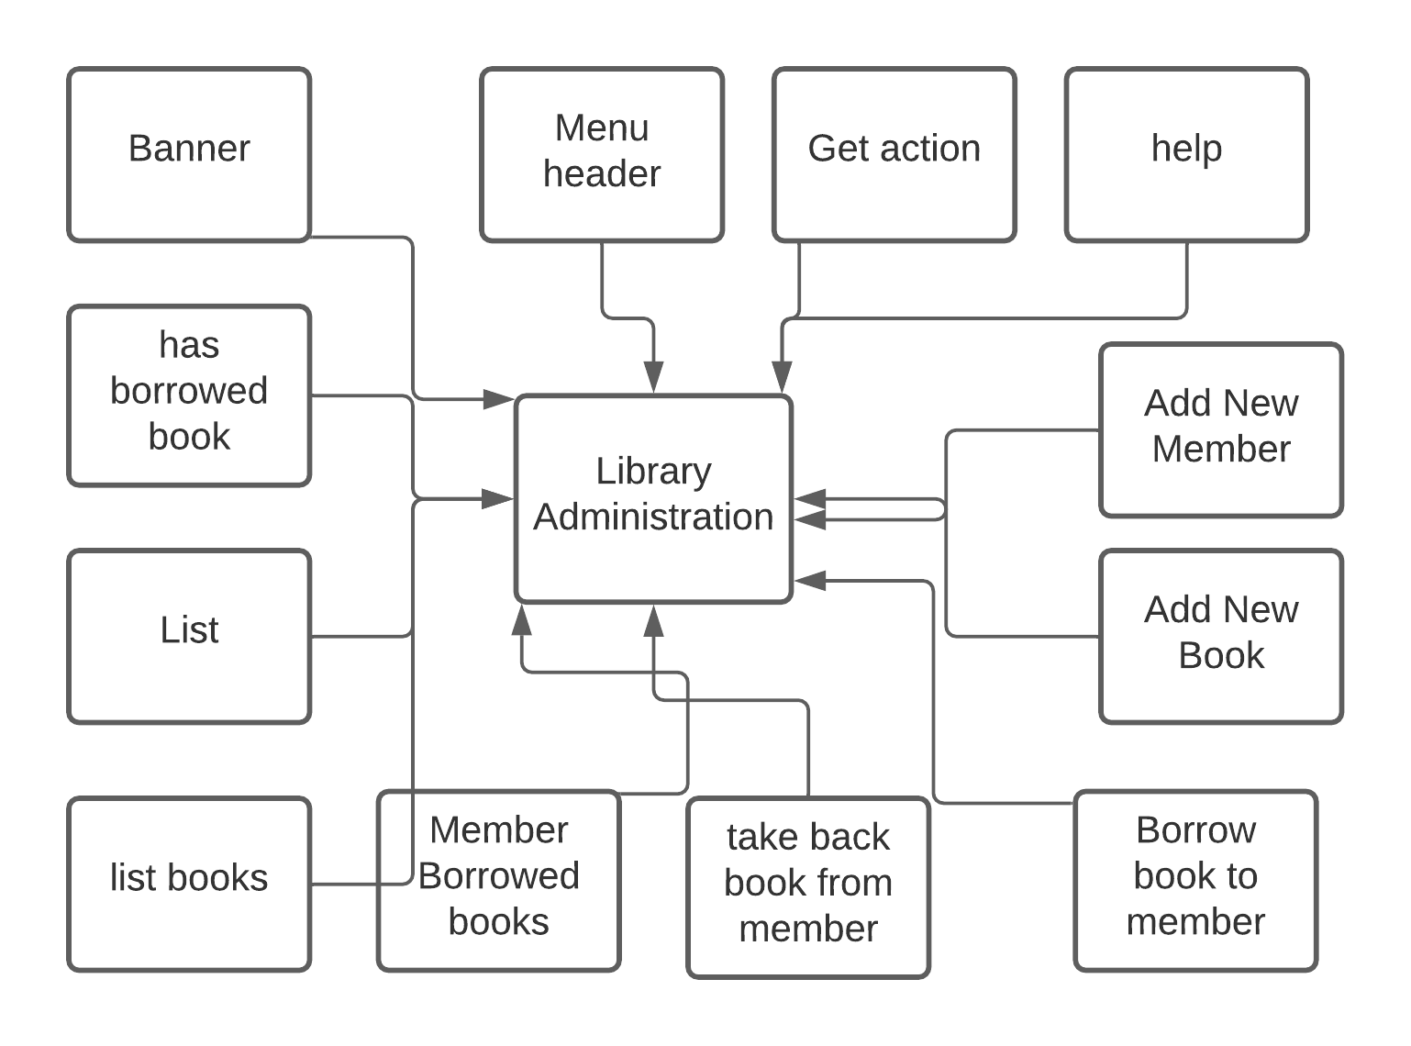

1. Activity Diagram

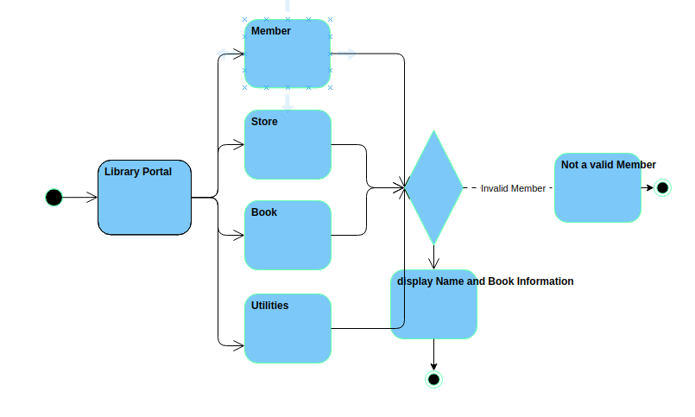

Structural Diagram

1. Class Diagram

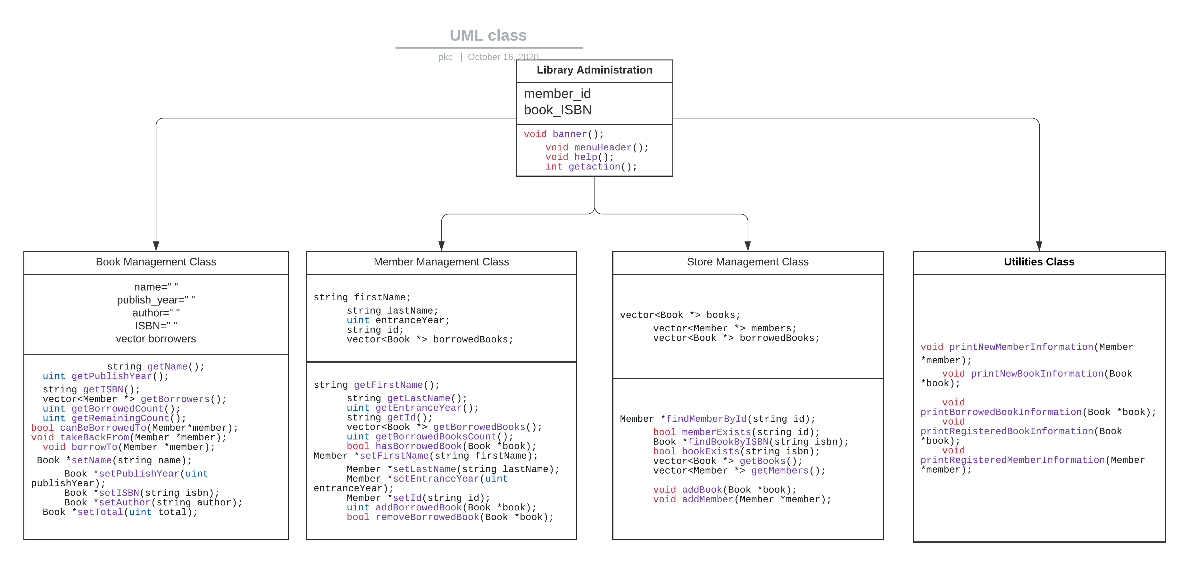

## Test Plan

High Level Test Plan (Integration Test Plan)

|  |  |  |  |  |  |
| --- | --- | --- | --- | --- | --- |
| **Test ID** | **Description** | **Precondition** | **Expected IO** | **Expected OP** | **Actual OP** |
| H1 | Management of Library book information | Set name of author, ISBN, book, publish year etc. | Set using inputs to the console | Successful set of Book details | Successful set of Book details |
| H2 | Management of Library Member Information | Set name of member, entrance year, id, borrowed books | Set using inputs to the console | Successful set of Member details | Successful set of Member details |
| H3 | Finding member and books using id | Get the id and ISBN set from the user | Set using inputs to the console | Find member and books using id and ISBN | Find member and books using id and ISBN |
| H4 | Provide library Utilities to Members | Get the command of utilities from user | Get the command of utilities from user | Successful completion of user command | Successful completion of user command |

Low Level Test Plan (Unit Test Plan)

|  |  |  |  |  |  |
| --- | --- | --- | --- | --- | --- |
| **Test ID** | **Description** | **Precondition** | **Expected IO** | **Expected OP** | **Actual OP** |
| L1 | Get the information about book | Set ISBN and author name | Set using input Console | Successful information about book | Successful information about book |
| L2 | List out books which can be borrowed to member. | Enter member id | Set using input Console | Members remaining book count | Members remaining book count |
| L3 | Set the information about book. | Name of Book, Author, ISBN, publish year | Set using input Console | Successful setting of book information | Successful setting of book information |
| L4 | Get Member information | Enter member id | Set using input Console | Successful information about Member | Successful information about Member |
| L5 | Set Member Information | Name, entrance year, id, Borrowed book list | Set using input Console | Successful setting of Member information | Successful setting of Member information |
| L6 | Get Member borrowed books count | Get Borrowed list data from book class using ISBN | Set using input Console | Get the number of books member has borrowed | Get the number of books member has borrowed |
| L7 | Check whether Member has borrowed books | Get ISBN of borrowed books | Set using input Console | Return true if ISBN matches | Return true if ISBN matches |
| L8 | Find Member by id | Member ID | Set using input Console | True if ID matches | True if ID matches |
| L9 | Print New Member information | Member name, id, entrance year, | Set using input Console | Display Member Information | Display Member Information |
| L10 | Print Borrowed book information | Get book name, author, ISBN, publish year and book count | Set using input Console | Display Borrowed book information | Display Borrowed book information |

## Implementation Summary

Library Management System is working with required functionalities.

### Video Summary

“Please upload a short video on the repo for the walkthrough of the project (Team/Individual) less than 7min and less than 30MB File Size. Start is the Standard opening slide with title of Mini Project + Team members followed by the walkthrough”

### Git Link

### <https://github.com/99002503/Mini_Project>

### Git Dashboard

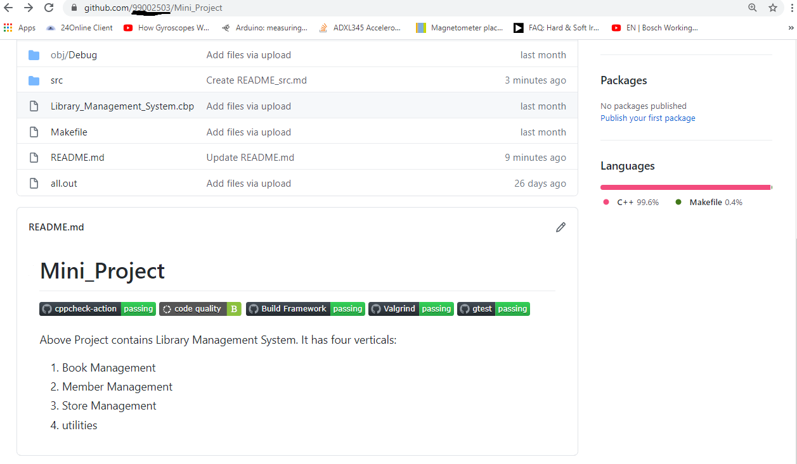

#### Git inspector summary

“In linux install gitinspector and Run the command –

gitinspector -H -l -m -T -w -r --grading --format=html > gitinsp.html

and upload the same to your repo and paste the snapshot in the report”

#### Build

Make file and all.out file was created.

#### Code quality and Issues or Bug Tracking

“Brief on code quality, errors and warnings flagged (issues created) and fixed”

Code quality: B

Warnings Flagged: Improve Code quality from B to A.

Status: should be fixed.

#### Unit Testing

“Unit Testing setup alignment with test plans and summary of outcome”

## **Individual Contribution & Highlights**

It is an Individual project.

### Challenges faced and how were they overcome

Usage of Collection was challenge. Self-learn and practice helped to overcome.

### Future Scope

Integration with Database using MySQL.

### 

# Miniproject -2 [Team/Individual]

## Module/s

### Topic and Subtopics

## Objectives & Requirements

## Design

## Test Plan

## Implementation Summary

### Git Link

### Git Dashboard

### Summary

#### Git inspector summary

#### Build

#### Code quality

#### Unit Testing

#### Issues

## Individual Contribution & Highlights

### Summary

### Challenges faced and how were they overcome